
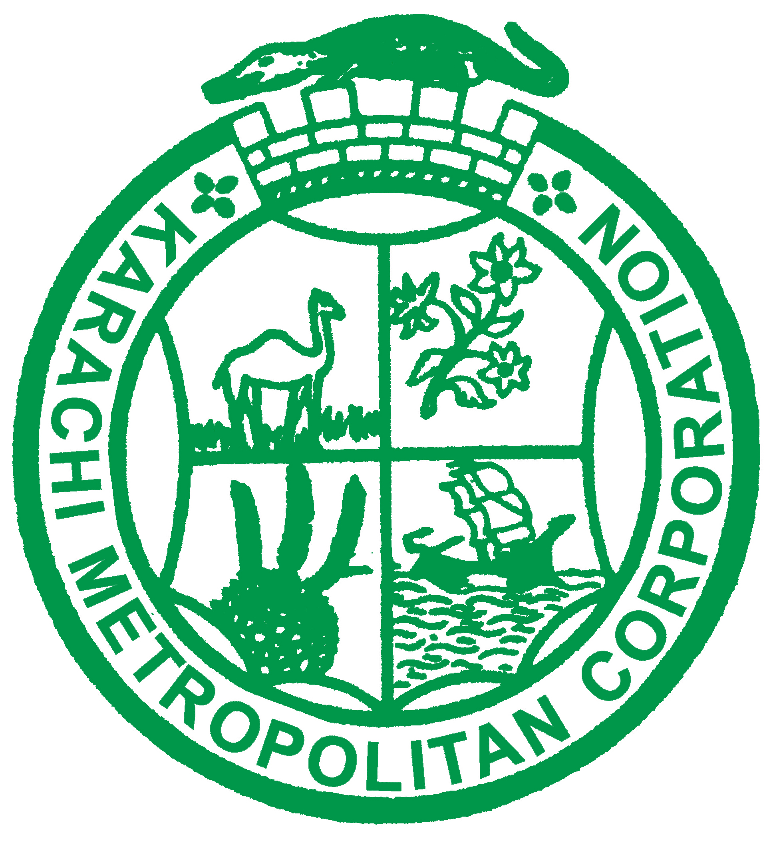
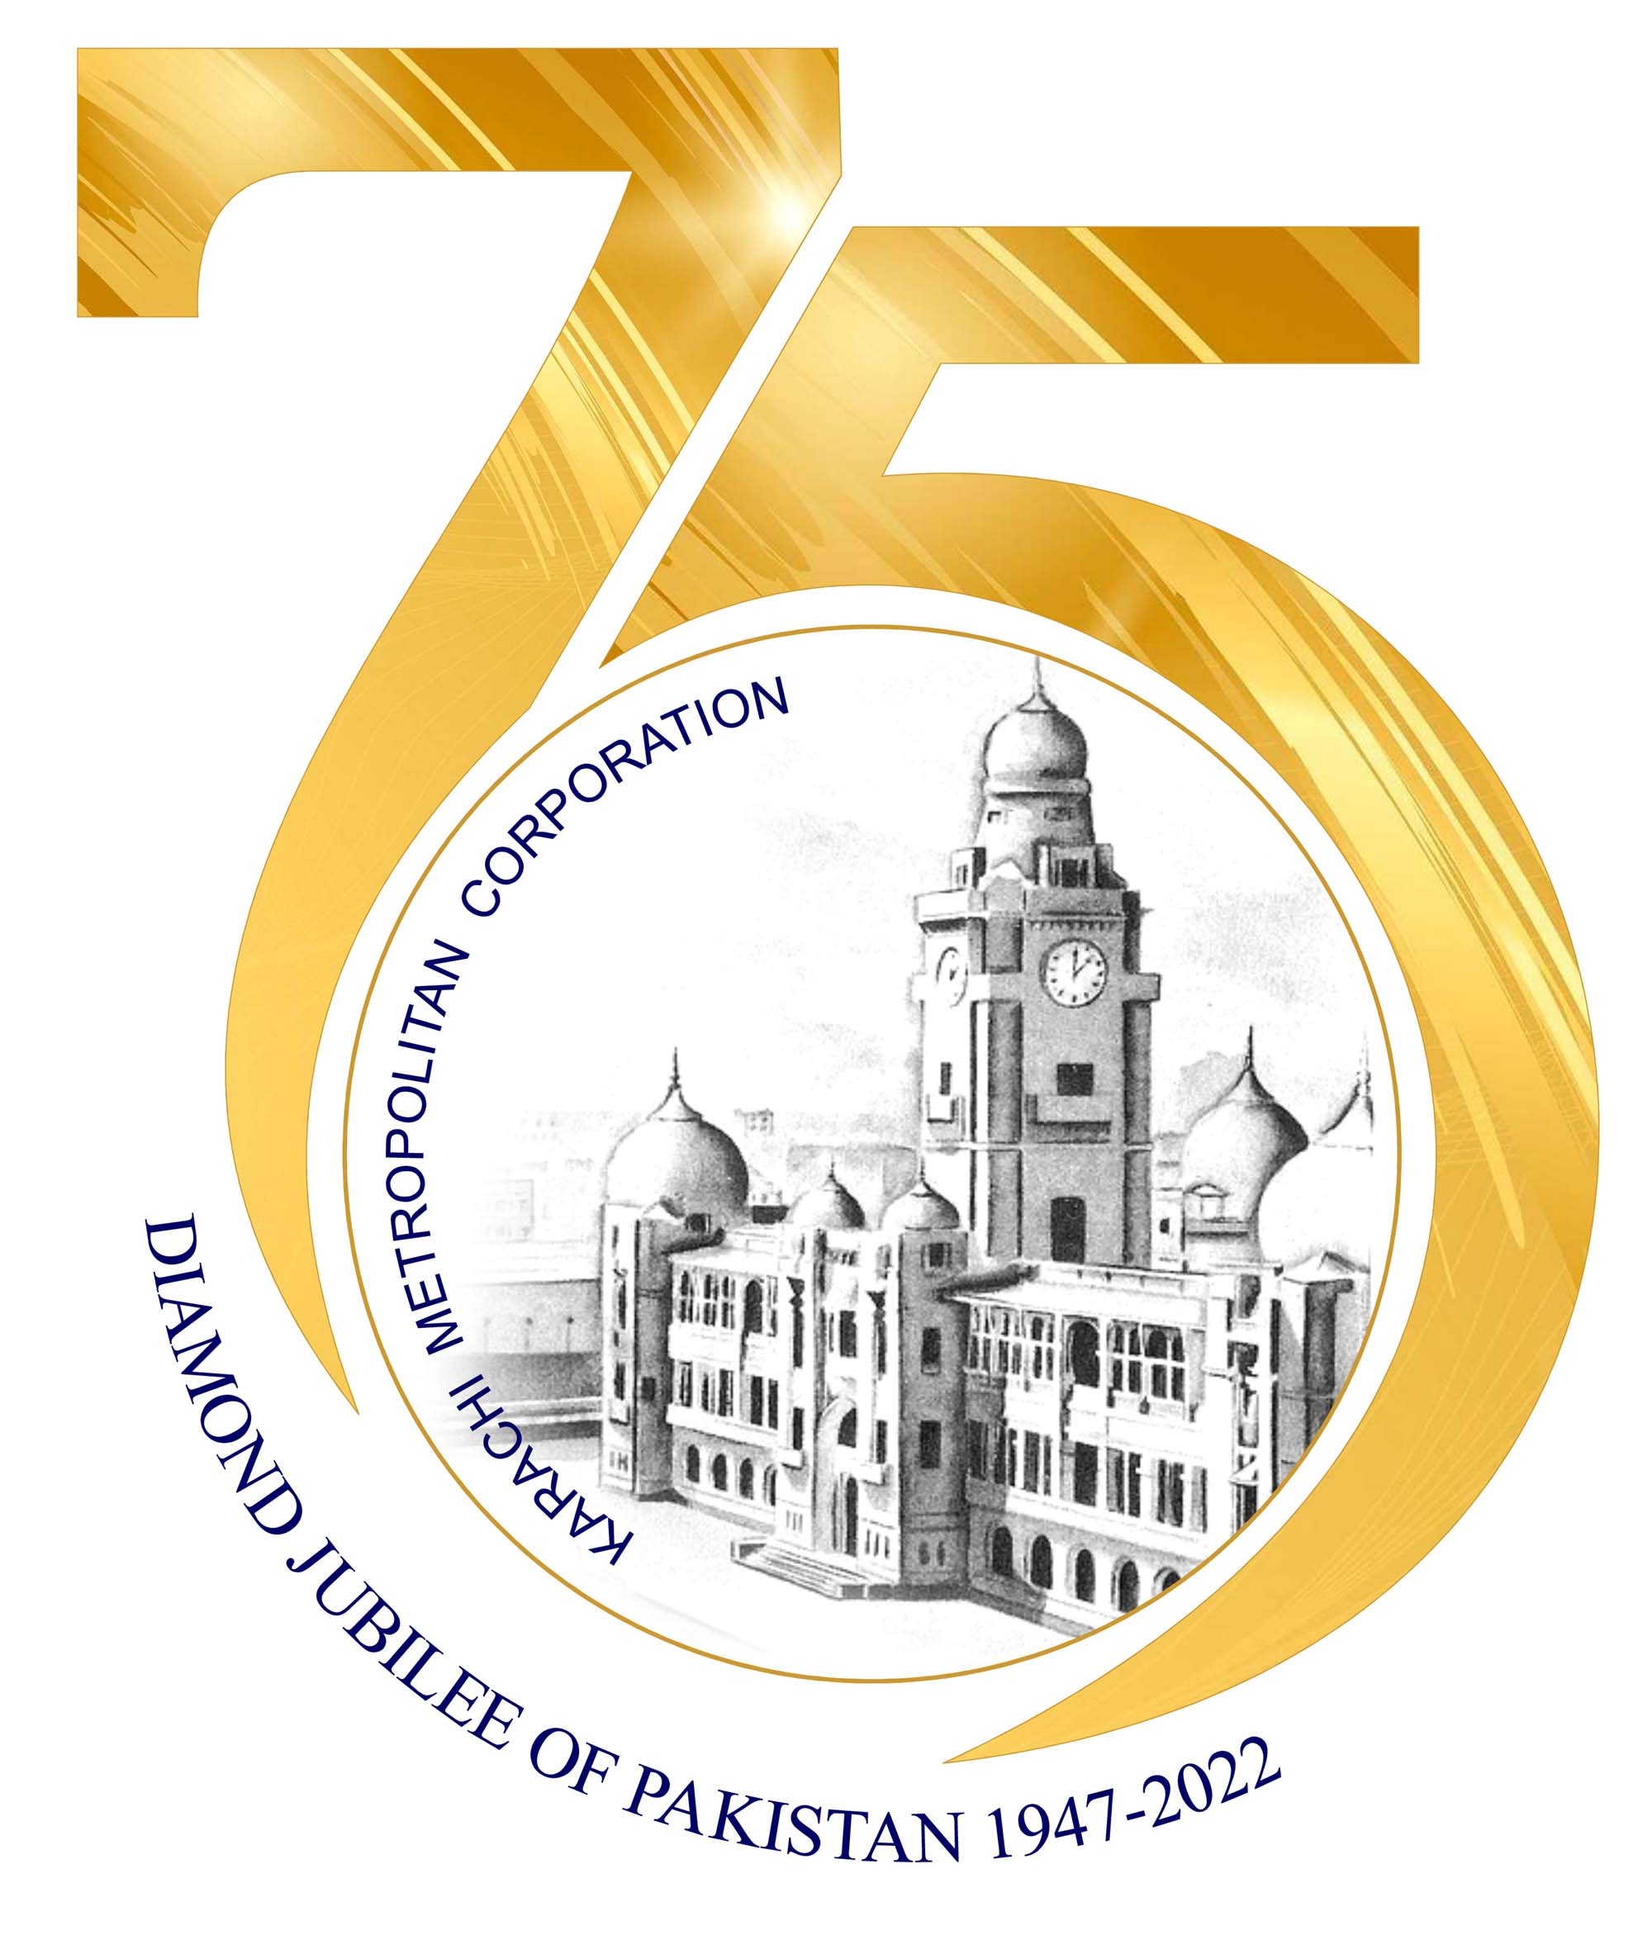

PRESS RELEASE
Phone: 99215134 - 99216335
Ref.No. KMC/INF/017/2025 Date: 10/01/2025
E-Mail: kmc.information.dptt@gmail.com
KARACHI METROPOLITAN CORPORATION

Karachi, Jan 10: Mayor Karachi Barrister Murtaza Wahab has announced that anti-corruption authorities will be approached against towns in District Central that have either permitted road cutting or engaged in such activities. He criticized the destruction of roads constructed at a cost of millions of rupees and stated that even though residents are not receiving gas, roads are still being dug up for gas line installations, which is unacceptable.

He added that the first phase of the Malir Expressway would be formally inaugurated on Saturday, showcasing to travellers who is actually working for the city and who is merely making claims. Speaking at the fifth annual flower show organized by KMC’s Parks and Horticulture Department at Bagh-e-Jinnah, Frere Hall, he revealed that over 100,000 marigold and petunia flowers were displayed at the event. While Karachi is not traditionally known as a city of flowers, efforts are being made to change that perception.

Deputy Mayor Salman Abdullah Murad, Parliamentary Leader Karamullah Waqasi, Deputy Parliamentary Leader Dil Muhammad, Jumman Darwan, Director General Parks Ikhlaq Khan Yousafzai, and other officials and elected representatives were also present on this occasion. Mayor Karachi emphasized that City Council members representing all languages, ethnicities, and districts of Karachi joined him at the event, reflecting a commitment to inclusive, non-discriminatory politics focused on the city’s development.

He stated that Karachi’s ongoing developmental journey is advancing at full pace. After the first phase of the Malir Expressway is inaugurated, the second phase will be completed by March, and the project will extend to Kathore near the Super Highway by December 2025. This initiative aims to significantly improve the city’s traffic system and ensure smoother traffic flow within Karachi.

Mayor Karachi Barrister Murtaza Wahab claimed that the quality of developmental work in Central District surpasses that of any other district, with the primary objective being to provide facilities to the common citizen. Representatives and workers of the Pakistan Peoples Party are working hard at all levels to achieve this goal. Alongside improving Karachi’s basic infrastructure, efforts are being made to upgrade parks with modern facilities, manage tree plantation projects, and establish urban forests. Collaborations with various organizations have advanced work on beautifying and greening the city’s roads and highways.

The flower show, part of these broader initiatives, will continue for the next three days. Citizens are encouraged to visit with their families and enjoy the event. Mayor Karachi highlighted that the purpose of the show is to enhance Karachi’s charm while raising awareness about caring for plants and trees. He urged citizens to nurture and irrigate greenery, transforming Karachi into a city of flowers, plants, and trees.

End.
KMC News and photos are also sent via e-mail. Please check your inbox

